** Credits to Heart Over Mind for this elaborate proposal**

DIGITAL LITERACY PROGRAMME PROPOSAL

Prepared for:  New Hope Community Services | Created by:  Heart Over Mind

Date:
16 July 2020

TABLE OF CONTENTS

1. SUMMARY 3
2. ABOUT HEART OVER MIND 3
3. INTRODUCTION: BACKGROUND 3
1. Digital Literacy in 21st Century 3
2. Seniors in Singapore and the low-income/homeless 4
3. Befriending/Social Support for Elderly 4
4. PROJECT IDEA 5
1. Description 5
2. Goals and objectives 5
5. PROJECT PLANNING 6
1. Delivery and structure 6
2. Considerations 6
1. Location 6
2. Befriender-to-client ratio 7
3. Resource manual style 7
3. Evaluation 8
1. Weekly homework 8
2. Pre- and post-survey 8
3. Befriender debrief and feedback 8
4. Funds 8
5. Logistics 8
6. Volunteer management 9
6. BUDGET 12
7. PROPOSED TIMELINE 12
References 13
APPENDIX 16
APPENDIX A 16
APPENDIX B 28
APPENDIX C 29
APPENDIX D 31
APPENDIX E 33
APPENDIX F 37

SUMMARY

Tête-a-Tech is a digital literacy project that aims to merge befriending and imparting technology knowledge into a single programme to promote digital literacy in seniors, as well as for them to feel more socially connected.

The programme considers the needs of a senior in a nation that aims to integrate technology into the daily lives of its citizens. To navigate effectively in this digital nation, seniors need to see the value of technology in their lives. Besides efforts from the seniors to overcome the steep digital learning curve, other stakeholders can be brought in to help make the curve gentler. This will be achieved through bringing in Volunteer Teachers and Volunteer Befrienders, a group that is younger and likely more adept in technological function, to guide and support their learning. Through this, feelings of social support in seniors may be increased and intergenerational bonding is being fostered.

Ideally at the end of the programme, seniors will become more confident and competent in using Android smartphones, taking away more than just practical digital skills and gain a youthful friend.

ABOUT HEART OVER MIND

Heart Over Mind (HOM) is a ground-up initiative started by a group of tertiary students wanting to reach out to the community. From the reports of various news sources during the government imposed ‘circuit breaker’ (CB) period, the members came to realise that the vulnerable groups in the community are going through as much a tough time like everyone else and feel less supported than usual.

These compassionate and empathetic feelings led the group to think about what can be done in their capabilities to help. Their efforts can be summarised with their motto: ‘We help them, help us, help them’. As HOM come up with ways to keep the vulnerable safe at home during the CB period, it benefits the whole community to make the CB measures more effective, in turn aiding in the mission to protect them.

With CB ending, this may no longer be as relevant. However, the team, at its core, still wants to protect, empower and echo doing more for the vulnerable.

INTRODUCTION: BACKGROUND

Digital Literacy in 21st Century

In 2014, Prime Minister Lee Hsien Loong launched the Smart Nation plan for Singapore to become a place where people live meaningful and fulfilled lives, enabled seamlessly by technology with exciting opportunities offered to all (Lee, 2014). Since then, many initiatives were introduced, both in the public and private sector. There is the revampment of SingPass, digitalisation of many government services such as CPF and IRAS (Accenture, n.d.), and in recent times, the development of the TraceTogether app.

Industries have also taken the opportunity to digitise their programmes and processes, like Internet Banking being promoted as the new default to encourage customers to perform transactions online (Chin, 2015). Aside from this, various applications were developed to improve the quality of life of Singaporeans. Examples such as bus-timing and e-commerce applications have brought greater convenience and have helped Singaporeans connect with one another.

From this, it is evident how technology has been integrated into daily lives of Singaporeans and shows the importance of being digitally literate to navigate effectively. While it might be easy for the younger generation to integrate technology into their lives, the older generation might be less able to adapt and adopt changes as quickly. For a country like Singapore facing an aging population, the senior is an important group to educate and train before larger systemic changes can be made.

Seniors in Singapore and the low-income/homeless

Singapore is rapidly aging. In 2019, 14.4 percent of the population is made of those aged above 65 (Hirschmann, 2020a). 15 years from now in 2035, this number is projected to be at 32 percent (Hirschmann, 2020b). Many aspects of Singapore will be affected by this trend and a nationwide shift to embrace the aging population is necessary as the country moves forward. A group that is often overlooked here is the homeless. In the recent nationwide street count, it was shared that the homeless population in Singapore are generally older adults holding volatile jobs that do not pay much (Ng, 2019; Liew, 2019). This means they likely form up the statistic of elderly living in poverty, which is estimated to be 6 in 10 of them (Cunico et al., 2017). With a median monthly wage of $1,400, those in poverty barely have enough for basic subsistence, which at least requires $1,379 (Lim, 2019; Liew, 2019).

There are various social interventions by government organisations and groups providing transitional shelters in a bid to alleviate the homeless’ pressing financial and housing issues. Together, they form the Partners Engaging and Empowering Rough Sleepers (PEERS) network (Ong, 2020).

Befriending/Social Support for Elderly

Loneliness is a serious problem for older people. In recent years, loneliness in elderly has been an increasing concern highlighted in the media. As reported in the 2014 Longitudinal Survey of Social Isolation (National Volunteer & Philanthropy Centre, 2017), more than 1 in 2 of seniors above age 60 said they were lonely. This is not only seen in those living alone, but those who live with family members as well.

Social support is a powerful tool that can help in alleviating loneliness (Chen et al., 2013). Strong social networks with high levels of social support is a protective factor for maintaining good health and quality of life in old age (Seeman et al., 1996), which is less associated with psychological distress in the elderly (Bøen et al., 2012). This may be achieved through befriending, which is a relationship shared between individuals initiated, supported, and monitored by an organisation that has defined one or more parties as likely to benefit. In a befriending relationship, it is typically sustained by being accepting and committing to building a solid companionship that is reciprocal (Dean & Goodlad, 1998). Even though there is currently a lack of study on how befriending helps in building a social support system, having someone to converse with is something both befrienders and befriendees highlighted as important and a relationship worth investing in.

  - Homeless/low income seniors in the COVID-19 pandemic and the importance of digital competency

As the government and private companies continue to phase out older practices, the older generation is struggling to continue using services that have now taken a more digital presence. At the same time during the COVID-19 outbreak, while younger Singaporeans are able to seek solace by interacting with friends via online platforms to maintain social contact, the seniors, of whom a sizable proportion of them are less tech-savvy, are unable to do so. A nationwide shift to focus on enabling seniors to be digitally competent is hence necessary or it will only get harder for seniors to feel integrated into the society.

In the 2018 Visa Digital Inclusion Study found that 84 percent of the seniors aged between 50 and 80 are smartphone owners (Baharudin, 2018). This is a positive sign as it suggests seniors are in greater embracement of technology and its uses. However, not many are well-versed in all types of apps in the app market. In fact, a number of seniors are unsure of how to use apps and afraid of ‘accidents’ happening where they are unable to undo an action they performed (Toh, 2017). Hence, even though they are not completely averse towards digitalisation, the seniors are not completely able to participate and be digitally included.

In response to this, the government has launched the IMSIlver and the PA Seniors for Smart Nation Programme to inform and teach seniors and the less tech-savvy to maintain their relevance in the digital world (Smart Nation and Digital Government Office, n.d.).

PROJECT IDEA

4.1 Description
Tête-a-Tech is a digital literacy program that aims to boost the digital competence and social support of the seniors in the homeless community. The project name is a spin-off from the French word, tête-à-tête, which stands for a dialogue between two individuals. As the seniors are equipped with more digital knowledge, their social network will also be strengthened as they build a relationship with the Volunteer Befriender (VBs) which they will be paired up with.
The sessions will focus more on covering breadth than depth beginning with stock apps, to communication and lifestyle apps. Opportunities for befriending and collaboration between the VBs and the seniors will be weaved into the sessions so that the seniors can learn and have fun at the same time.

Goals and objectives
The main goal of Tête-a-Tech is to equip seniors with basic skills to use technology through fun and interactive activities. More than just highlighting the importance of technology in the senior’s daily lives, the programme also serves as a platform for the broadening of social networks.
By the end of the programme, at least 80 percent of the seniors should feel confident in using smartphones and show at least a 1-point improvement in confidence in using technology. This will be measured through a pre- and post-survey with scoring scales. The senior should also be able to complete all homework given as an assessment to their comprehension of the content covered.

PROJECT PLANNING
5.1 Delivery and structure

The project will take place over a total of 11 sessions, using face-to-face delivery. Each 2 hour session will have a different focus area, starting off first with introducing the physical parts of the smartphone, the basic functions of stock applications, followed by other applications in the communication and lifestyle categories. Every senior will also be paired up with a VB to assist them in their learning. Since the seniors understand and converse in their mother tongue language better, each class will be split into 4, with each group conducting the sessions in Chinese, Malay, Tamil and Basic English. For a more detailed description of each session, please refer to Appendix A.

To prevent overwhelming the seniors with information, each session will only focus on one category of applications and will have at least a 5 minute intermission for VBs and their senior to recap on the contents covered. This will help to keep the information palatable for the seniors, as well as give them time to assimilate the new information given. The topic for each session will also be grouped into smaller sub-parts. Mini activities are included at the end of each sub-parts to serve as a checkpoint to evaluate the learning of the seniors. At the end of each session, homework will also be given for the seniors to attempt applying what was taught in class independently. A physical manual will be provided as a resource for self-learning and recap for the seniors in their free time. The contents will be sorted according to what was taught in each session, including homework activities.

Since one of the project goals is about strengthening the social support network for the seniors, the very first session conducted will be one with icebreaker games for seniors and their VB to warm up to each other. For the subsequent sessions, all of them will start off with a 10 minutes introduction, in which the contents to be covered in that session will be shown. In addition, this time can be taken for the seniors and their VB to share about their week or go through difficulties the seniors face doing the assigned homework.

On the last session of the project, there will be a small ceremony to present to the seniors a certificate of completion.

Considerations

There are several considerations that will be listed in this section, including: location, befriender-to-client ratio and resource manual style.

Location

The locations considered are those within 4 kilometre radius of the New Hope Transitional Shelters at Jalan Kukoh. This is to minimise travelling in case of mobility problems in some of the seniors. Currently, the plan is to conduct the session at 1 Jalan Kukoh using the activity centre owned by New Hope Community Services. In the event that is not possible, Tiong Bahru Community Centre will serve as a backup location.

 | Tiong Bahru CC | 1 Jalan Kukoh
Accessible by foot | ╳ | ✓
Accessible by public transport | ✓ | ✓
Rental fees | ╳ | ✓
Facilities and resources | ✓ | ✓
Existing programmes taking up the space | ╳ | ╳
Table 1. Considerations for location

Befriender-to-client ratio

As the contents covered may be too complex, there are VBs for the seniors to support them in their classroom learning.

Even though more manpower is required for a 1:1 ratio, the priority is to ensure that each senior is able to adequately grasp what is taught. Hence, it is important for VBs to place their focus on just one of them. Having a 1:1 ratio also prevents the possibility of one of the seniors feeling left out or unsupported in the 1:2 ratio scenario.

 | 1:1 | 1:2
Manpower | ╳ | ✓
Quality of interaction | ✓ | ✓
Attention span per seniors | ✓ | ╳
Table 2. Considerations for befriender-to-client ratio

Resource manual style

The purpose of the resource manual serve as a guiding material for seniors to refer to when they require help with their homework, or for future reference for app usage when the programme has ended.

HOM has noted that laminated cue cards require additional resources and are prone to misplacement. The separate resource manual can provide convenience for reference and prevent confusion.

Please refer to Appendix B for a sample of the resource manual.

 | Laminated cue cards | Online slides
Accessibility to information | ✓ | ✓
Durability | ╳ | ✓
Usability | ✓ | ╳
Resources required | ✓ | ✓
Table 3. Considerations for resource manual style

Evaluation

Weekly homework

To evaluate the learning of the seniors, there will be homework given on selected weeks for the seniors to practise what they have been taught in their own time before the next session. Homework instructions will also be included in the take-home cue cards. Each session will begin with an introduction, in which VBs can take the time to guide the senior if they have any difficulties doing the homework from the previous week.

Pre- and post-survey

A pre-survey to assess the digital competence of each senior will be given out in the first session. In the last session, a post survey will be given out to gather the same data after attending the programme as well as obtain any relevant feedback. The two sets of data collected will be compared to find out the effectiveness of the programme. Information on the pre- and post-survey can be found in Appendix C.

Befriender debrief and feedback

At the end of each session, VBs will stay behind for a 20 minutes debrief. During the debrief, VBs will share about their senior’s progress, highlight any issues experienced, and share their reflections for the day. Having a reflection session immediately ensures that the VB’s experiences are fresh in their minds. This also allows VBs to revisit their own reflections again at a later time on their own accord, further enhancing learning from the experience. At the same time, VBs are required to submit a weekly progress report of the seniors for evaluation on the team’s end.

Funds

The acquisition of funds will be done through cause-related marketing (CRM). HOM is intending to conduct a bake sale in collaboration with Cheybakes, an online home-based business belonging to one of our team members. More details will be worked out at a later date for the fundraising.

Logistics

HOM has categorised the logistics into four different categories:

Category | What it mainly encompasses
Classroom materials | Resource manual, furnitures, slides and phones
Games/activities | Stationeries, paper products
Prizes | Phone cover, cord protector and certificate
Device-related | Charging accessories
Table 4. Logistics categories

New Hope Community Services has mentioned in the email that they will be able to provide tables, chairs whiteboard and a projector. Some of the rest of the materials will be purchased online, whereas some will be purchased in physical stores.

A more detailed logistics list can be found under Appendix D.

Volunteer management

    - Recruitment and matching

A total of 20 VBs will be recruited through HOM’s official Instagram page. They will be considered for their perceived confidence in guiding another person, proficiency in usage of different categories of phone apps, situation awareness as well as their language (See Table 5 below). The matching of VB to a senior will be arranged depending on the compatibility of the first language between the VB and the senior.

HOM will also be recruiting 3 other Volunteer Teachers (VTs) to conduct Tête-a-Tech sessions in Chinese, Malay and Tamil language. These VTs will be assessed primarily on their speaking abilities for their mother tongue.

All volunteers will have to meet the minimum age requirement of 15 years old to volunteer with us. An example of the recruitment form can be found in Appendix E.

 | Criteria | Format | Justification
 | Perceived confidence in guiding another person | Statement with linear scale response type | To ensure that the applicant is comfortable in guiding and provide timely learning support to another individual.
 | Proficiency in various categories of phone apps | Statement with linear scale response type | To gauge the applicant’s knowledge and familiarity with the functions and workings of the apps that will be taught in class.
 | Situational awareness (in the form of situational type questions) | Situational questions with short answer | To assess applicant’s response to the needs of the seniors.
 | Proficiency in language and dialects | Statement with linear scale response type | To ensure that applicants are able to communicate with the seniors effectively.
 | Proficiency in mother tongue (speaking) | Statement with linear scale response type | To ensure the applicants are able to conduct the class in their mother tongue.
 | Table 5. Recruitment criteria and justification

- Roles and responsibilities

The main role of a VB is to be a friend to their partnered senior and support their learning of their partnered senior during Tête-a-Tech sessions. This includes doing thorough recaps of lesson content, troubleshooting app-related issues the senior face, and participating actively in class activities with the senior. VBs should also make it a point to make a genuine connection with the senior. Along with that, they are required to maintain and submit Google Forms of records of the senior’s weekly progress to HOM, and address them accordingly in the weeks to come. During debrief sessions, VBs are encouraged to share their experiences openly and provide valuable feedback on improvements to be made.

The main role of the VT is to conduct Tête-a-Tech sessions in their mother tongue language to the seniors. To ensure that VTs are knowledgeable and sufficiently prepared for teaching, they will need to commit to weekly meetings with HOM to run through the class content. Like the VBs, they are also required to attend debrief sessions and encouraged to share their experiences openly with HOM.

- Training
Prior to the start of Tête-a-Tech sessions, all volunteers will be required to attend a compulsory Volunteer Training by HOM. The training will cover the

- Vision and mission of HOM;
- Vision, mission and service of New Hope Community Services;
- Goals, objectives and Tête-a-Tech;
- Description of Tête-a-Tech;
- Timeline
- Roles and responsibilities of VBs
- Roles and responsibilities of VTs
- Volunteer do’s and don’ts
- Volunteer Code of Conduct and PDPA form submission

At the end of the training, volunteers will go through an assessment quiz to check their understanding of the training.

BUDGET

The total estimated amount for the entire project is $604.67, assuming an attendance of 20 seniors. The simplified breakdown is as follows:

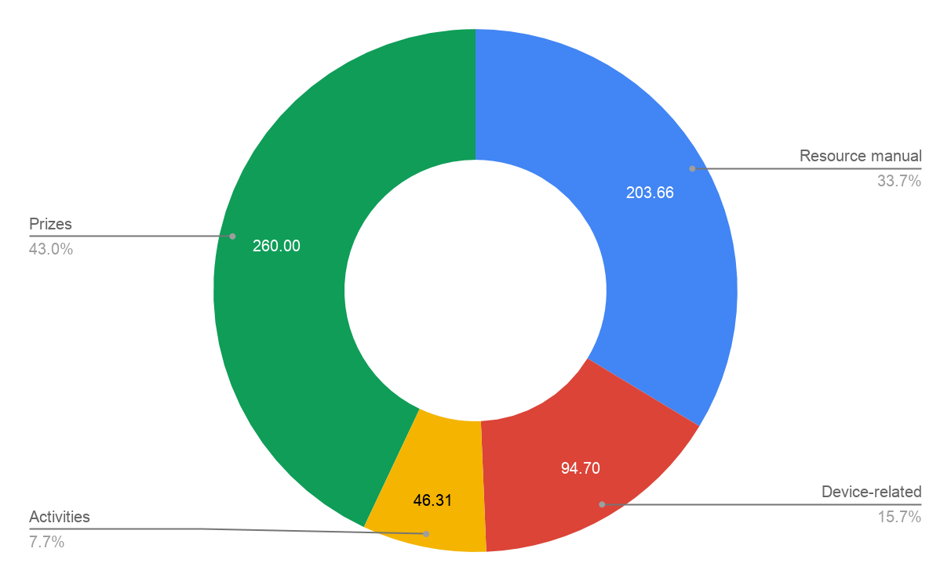
Figure 1. Simplified budget breakdown

The spending for prizes is the highest, amounting to $260.00. This includes the phone covers as well as USB cord protectors. Each phone cover should not exceed $10.00 and cord protectors should not cost more than $3.00.

The second greatest spending is on the resource manual, which takes into account printing and lamination costs, as well as investment in a ring binder. The lamination of the cue cards is necessary to extend the longevity and strengthen the durability of it, whereas the ring binder allows cards to be grouped together for easy carry.

For device-related spending, it covers purchase of USB cables and extension cords for the charging of devices. The seniors will be reminded to charge their devices before coming for class. To prepare for the event that any senior forgets to do so, or any devices run out of battery in the middle of the session, extension cords and USB cables are provided for charging. If the extension cords can be rented and if the seniors already possess USB cables, this amount can be saved.

For the logistics for classroom activities, the bulk of it is for the Amazing Race activity in Session 5.

For a detailed breakdown of the budget, please refer to Appendix F.

PROPOSED TIMELINE

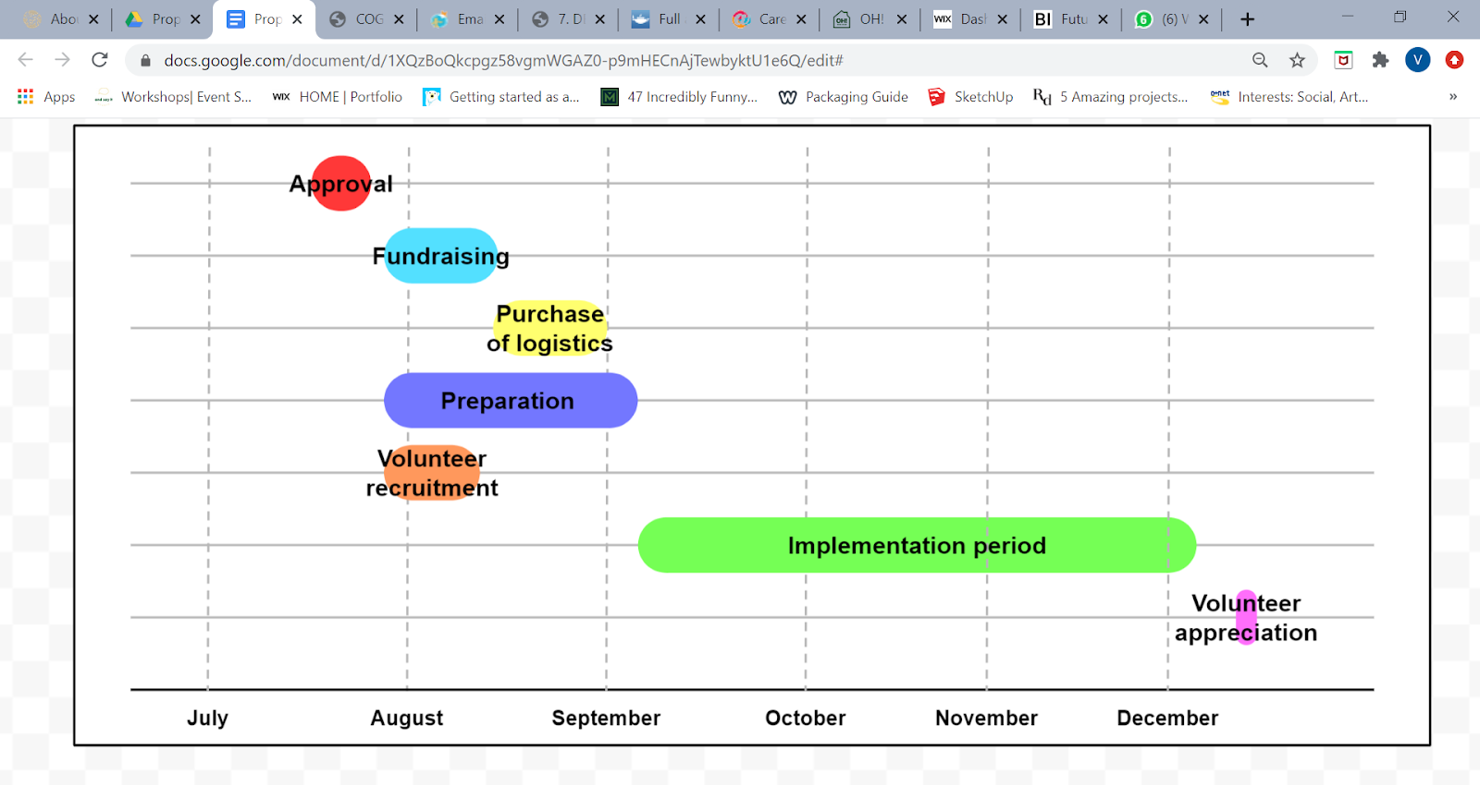
Figure 2. Simplified timeline of events

The estimation for the approval of the proposal will be 1 week. Volunteer recruitment and the purchase of logistics will then occur concurrently for two weeks, from end-July to mid-August. This takes into account the shipping period for logistics that will be purchased online, including the possibility of any shipment delays.

While fundraising is taking place, volunteer recruitment and preparation for the actual sessions will also commence. The project will officially kick off in the second week of September, lasting for about 3 months to the first week of December. Upon completion of the project, a small volunteer appreciation event will be held to thank the efforts of the volunteers.

APPENDIX

APPENDIX A

Proposed activity outline

Goals:
- To teach and enable seniors to be more adept at using basic smartphone functions as a tool for communication, navigation, documentation, audio-visual entertainment and productivity in 12 weeks
- To allow the seniors to see the value and usefulness of technology and how it can enhance their lives
- To widen the support network of seniors from displaced/low income families
- To make learning fun for the seniors

Session 1

Focus | Duration (min) | Topic | Description | Logistics
Icebreaker | 10 | Introduction | Everyone introduce their name
 | 15 | Know Your Pair | - Each pair will be given 5 minutes find out each other’s  - Favourite colour  - Hobby  - What they ate for breakfast  - Number of siblings  - Age  - Befrienders and seniors will be given 3 questions each based on their partner’s answers for any of the 7 things they were supposed to know about each other. No communication or hints are allowed!  - Write down the answers on a piece of paper split into 2 halves labelled clearly with the seniors and befriender’s name.  *Befrienders may offer to help their seniors’s answers if the seniors does not know how to write or spell  - Participants will raise their hands when done.  - Partners will proceed to check answers.  - Any pair who does not get all 3 answers right will do a dance forfeit together. | Pen/Markers  Paper
 | 15 | Matchy-Me | - Participants will receive a paper with an image but they will not know what they are  - Participants will have to figure out the image through questions while other participants can only answer ‘yes’ or ‘no’  - Participants (Befrienders) will find their buddy (seniors) with the same image | Paper
 | 15 | Draw On Your Head Game (Backup game) | - Participants will hold a paper plate on top of their heads  *Modification: Place clipboard on their lap and draw without looking at the clipboard  - Follow the instructions and screen display to draw  - A line  - A smiley face  - Three circles on top of the line  - A bunch of 10 grapes  - Follow verbal instructions to draw (No pictorial guide)  - A house (Triangle, rectangle, 2 small circles, 1 small rectangle)  - Turtle (1 semicircle, 1 small circle, 4 curved lines, grid lines)  - After each drawing is completed, everyone will raise their drawings for everyone to see | Pen/Markers  L-shaped files
 | 5 | Break
 | 15 | Introduction | - What we are going to cover over the next 11 weeks  - Uses of technology
 | 5 | Summary | - Get the seniors to rate the session out of 10

Session 2

Focus | Duration (min) | Topic | Description | Logistics
Basic smartphone | 10 | Introduction
 | 5 | Parts of a SP | - Introduce  - Power button, home button, volume button  - Nano SIM tray  - Speakers  - Headset jack  - Front and back camera, flashlight  - Microphone  - Fingerprint sensor  - Activity: Test on the different parts of the phone  - Insert picture of phone and colour code the different parts | 20 sets of 10 different colour cards  (Red, Orange, Yellow, Green, Blue, Purple, Pink, Brown, Grey, Light blue)
 | 10 | Home screen | - Go through steps to  - Turn on and off  - How to unlock/lock Session objective:  - Introduce the basic functions of a smartphone to the seniors  - By the end of the session, seniors should be able to navigate through at least 3 functions in a smartphone  - phone  - Home screen layout  - Notification/Status bar, battery percentage  - Home key, recent key, back key  - Introduce stock apps (Phone, Messaging, Contacts, Camera, Clock, Gallery, Calendar, Notes, Maps, Settings, Apps store, Mail, Music, Internet)
 | 5 | Recap/Break | Volunteers to recap with seniors parts of SP and home screen functions.
 | 10 | Settings | - Set date and time (manual setting)  - Ringtone  - Accessibility (Language, display and text size)  - Change wallpaper
 | 5 | Contact | - Adding and saving contacts  - Activity: Saving the New Hope’s contact
 | 5 | Phone and Message | - How to call someone  - How to text someone
 | 5 | Recap | Volunteers to recap with seniors setting date and time, contact, call and message function.
 | 5 | Summary and homework | - Class sharing of the different things taught today by seniors  - Homework:  - Find out & save 3 important contacts  - Creating a contact list of 3 other persons
 | 20 | Befriender debrief | - Sharing by befrienders and feedback

APPENDIX E

Recruitment form

Link to Google Form: https://docs.google.com/forms/d/14giLMa5bJ1_GvYG53n1e5klmHdOp8B45Q-dS-PrzHis/edit)

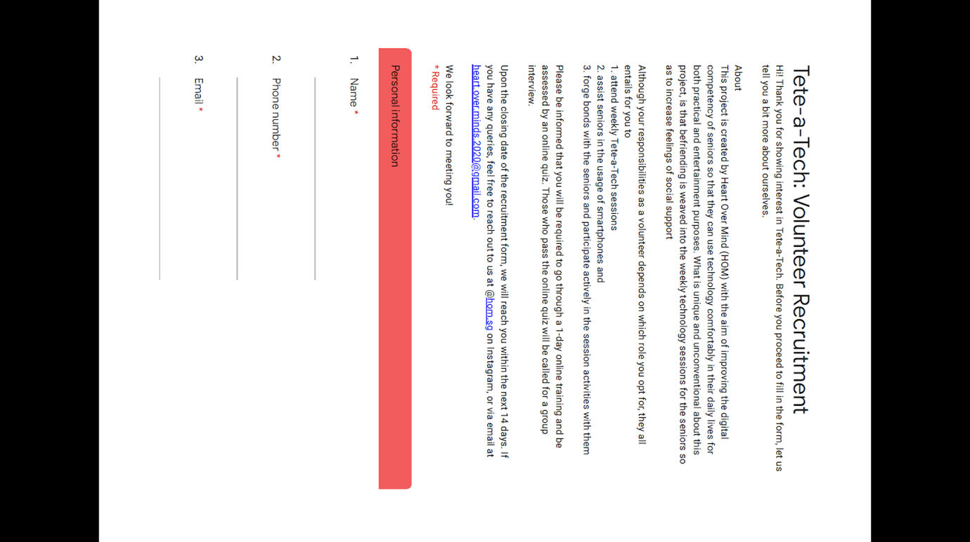

APPENDIX F

Budget (Assuming 20 seniors)

- Resource manual
- Activities related
- Prizes
- Device-related

Item | Cost | Quantity | Amount | Purchase location | Notes
Printing and laminating cost | 200.00 | - | 200.00 | - | -
Metal ring binder | 1.33 | 2 | 2.66 (+1.00) | https://shopee.sg/product/75777351/1830182103?v=0e7&smtt=0.0.10 | Metal Ring Binder (25mm, 10 pcs)
L-shape file | 3.90 | 2 | 7.80 (+1.69) | https://shopee.sg/product/7341551/1159519453?v=78e&smtt=0.0.10 | L-Shape Folder A4 Size (12 pcs)
Markers | 4.00 | 5 | 20.00 (+1.69) | https://shopee.sg/product/11564859/252128693?v=80d&smtt=0.0.10 | Fullmark Dry Erase Whiteboard Marker, Fine Bullet Point (4 pcs)
Paper clips | 0.37 | 1 | 0.37 | https://stationeryworld.com.sg/triangle-paperclips-31mm-pack-of-100 | Triangle Paperclips 31mm Pack of 100
Coloured paper | 1.28 | 2 | 2.56 | https://stationeryworld.com.sg/square-colour-paper-pack-of-40 | Square Colour Paper Pack of 40
Cups | 3.05 | 4 | 12.20 | https://www.fairprice.com.sg/product/homeproud-disposable-cups-50s-563719 | HomeProud Disposable Cups - Assorted Colours  Pack of 50
Phone covers | 10.00 | 20 | 200.00 | - | -
Cord protector | 3.00 | 20 | 60.00 | - | -
Extension cord | 17.90 | 3 | 53.70 | https://giant.sg/product/socket-ps-505-5068345 | SOUND TEOH  Extension Socket 5W2M PS505
USB cable | 2.00 | 20 | 40.00 (+1.00) | https://shopee.sg/product/196208971/4415142304?v=84c&smtt=0.0.10 | 3 in 1 Iphone Lightning USB Android Micro USB Type-C Fast Data Sync Charging Cables
TOTAL |  |  | $604.67

